Raffle Basket Update 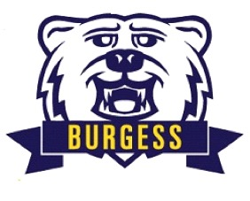

Thank you to all the families who have donated items to our Annual Basket Raffle. Without your donations, we would not have all these wonderful baskets. This year, we were able to surpass last years 29 baskets with a total of 38 BASKETS. Below is the updated list of baskets offered at this year’s raffle. There are a few added baskets due to the large amount of donations we received. More baskets means more winners.

1 Barbie

1 Sand & Slime

1 Things That Move (cars, planes, trains)

2 Playdough

2 New England Sports

3 Gift Card

4 Nerf

4 LEGO

4 Stem

4 Cooking

6 Family Game Night

6 Arts & Crafts

